**Street Quality Identification Device**

# ABSTRACT

In this paper, we describe the design and development of SQUID (Street Quality Identification Device), a low-cost sensor platform mounted on official city vehicles to passively measure street surface quality by combining a microcomputer, accelerometer, GPS and a camera to build an image database of the underlying street surface quality across the entire city. The collection of this data, at scale, would thus represent a low-cost baseline to make strategic and operational decisions about street resurfacing.

**Categories and Subject Descriptors**

Python, Linux, Sensor networks

**General Terms**

Algorithms, Management, Measurement, Design, Experimentation, Verification.

**Keywords**

Raspberry Pi, accelerometer, GPS, image processing, potholes, street defects, big data, common operational picture, situational awareness, decision making, internet of things, NYC Dept. of

Operations, Street Conditions Observation Unit, SCOUT

# INTRODUCTION

The maintenance of city streets is one of the most visible indicators of operational effectiveness of a city government [9] yet little is known about the “ground truth”, the actual extent of street defect quality. Current efforts in NYC involve a combination of citizen reporting and manual, “windshield surveying” of 6,000 road miles of city streets. In an age of driverless and connected vehicles, it is time for cities to adopt data driven approaches for street surface maintenance. Not only does a local government have the obligation to maintain the streets, but are also liable to damages from personal injury and property damage suits that result from these roadway defects. A recent report by the NYC Comptroller shows that during 20102015, the City of New York spent $138 million dollars to settle personal injury and property damage claims as a result of defective roadways [1].

New York City has also recently added $242 million additional dollars to existing repaving efforts to resurface 2,500 lane miles through 2017 [2].

__________________________

*Advanced Research in Government Operations or ARGO Labs is an initiative to pioneer a civic data science, to better understand and operationalize emerging trends in data driven decision making, analytics and instrumentation towards scalable & imaginative digital service delivery in local governments.

Theses challenges are not unique to New York City but any city that relies on road transportation. Several transportation research reports have highlighted the enormous costs of poor street quality on individual drivers [3] yet existing efforts to address street surface quality are, at best, stuck in maintenance mode with “no end in sight”.

Dr. Lucius Riccio at NYU who has studied the causes of potholes through empirical studies [5] calls this form of decision making, Orbital velocity and not attaining “Escape Velocity” towards better understanding the nature of the problem [6]. New York City, today, relies on 311 as a primary data source for pothole discovery. The 311 approach depends on input from citizens & city workers identifying location specific street defects. City agencies then allocate additional resources to verify whether a reported defect is actionable [7] further delaying the response to an already redundant and circular process.

We think that a focused, situated approach leveraging advances made in micro computing, data analysis, storage and image processing can transform this “whack-a-mole”, expensive & reactive approach to a more proactive, cost-effective & data driven approach that addresses the “missing denominator” [8] in street surface quality reporting and decision making. To this end we have prototyped a device using cost effective components, collected data from the field and demonstrate results to inform our discussion around achieving better situational awareness for street quality in a city.

# BACKGROUND

Few initiatives exist that involve the development of a low cost device to passively collect data about city street quality in a continuous, reusable manner. Previous attempts have been largely experimental involving a single specialized vehicle fitted with large, expensive, military grade sensor equipment that overengineers the problem without achieving scalable means to collect data necessary to make street resurfacing decisions. Moreover, these attempts have approached the problem as a techno-centric rather than systems centric. Our approach allows for a systematic approach recognizing the people and institutions involved in street maintenance operations. We recognize that the problem is complex and includes a large public facing component and is deeply embedded in several political bureaucracies. These issues are not in scope for this paper but our design philosophy recognizes this complex environment.

## Laser Profilometer of New York City streets

In 1998 and 2001, the Fund for the City of New York’s Center on Municipal Government Performance piloted a setup that included a laser-profilometer retrofitted to a city vehicle [9]. This was a city-wide survey of the streets which attributed a “smoothness” score and “jolt” score to every neighborhood and borough in the city.

The resultant data did not contain geographic coordinates and only served as a point-in-time survey of street quality. The reports generated gave an overall indication of how street quality varied throughout the city, but it was not comprehensive in the sense that it was made of samples and not an entire sweep of every street in the city.

The FCNY approach successfully demonstrated that a timely sweep of the city’s roads was possible by sensor driven data collection methods but was limited in demonstrating how such an approach could transition to routine repair efforts.

## Boston’s *StreetBump*

The City of Boston’s Mayor's Office of New Urban Mechanics has implemented a project called *StreetBump* [10] which is a mobile application that allows Boston residents to use their phone to passively measure street surface quality data. The app, when turned on is able to determine when the device is in motion and records the location of bump and jolts as the user drives around the city.. This data is then transmitted to city officials to be used for repair scheduling. If images from the locations of where bumps occur are available online, they can be associated with the data, although how this process works at a systems level is unclear.

We see several weaknesses with this approach. First, the data collection is dependent on residents downloading the application to their phone and having it running in the background as they drive. In an ideal scenario, the data collected would be persistent and distributed, but it fails to be comprehensive. Additionally, since the sensor is not situated, data integrity cannot be guaranteed as the readings will likely vary based on whether the phone is on the dashboard, on a seat, in a cup holder, or in the driver's pocket. Furthermore, without a consistent visual record of the underlying data, false positives cannot be easily screened. The StreetBump initiative also suffers from the operational overhead of committing an additional resource to verify whether the measured data is actionable.

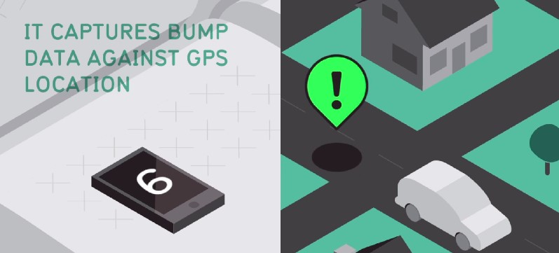

Figure 2: The City of Boston’s Mayor's Office of New Urban

Mechanics illustration of StreetBump

## FUGRO

FUGRO, a multinational company is a specialist in integrated geotechnical surveying services

built a product called ARAN, an automated pavement and road analyzer that uses military grade sensors and a dedicated van to profile highways (FUGRO). A typical "sweep" may cost up to a million dollars and take several months for data to be acquired and processed [12]. A few cities have used FUGRO’s ARAN to assess the arterial and collector roads against the International Roughness Index.

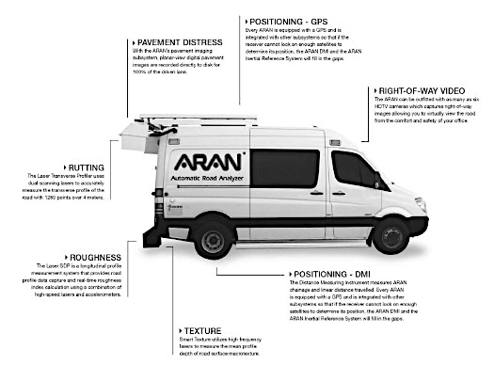

Figure1: FUGRO’s Automatic Road Analyzer

The City of Pittsburgh is also collaborating with Carnegie Mellon University’s Traffic21 research initiative [14] to deploy a similar approach of using cameras in city vehicles to automate the process of detecting and reporting street defects. Our approach to this problem is unique in that it addresses the need to develop a cost effective *baselining* program that can be mounted non intrusively on a city’s existing fleet, collect data in a similarly comprehensive manner to facilitate targeted decisions about street surface quality interventions.

# STREET QUALITY IDENTIFICATION DEVICE

Street Quality Identification Device (SQUID) is the combination of a microcomputer and associated sensors installed in a nonintrusive form factor to passively collect data in a scalable manner towards achieving a citywide map of street defects. In this section, we describe the design and development of the device itself, the data that it will emit and the decision making that can be facilitated by a citywide map of street defects.

## Device

SQUID is built using consumer grade electronic components. The core component is the Raspberry Pi 2 [13], a small Linuxbased computer. The Pi processes and stores all data collected from attached sensors and peripherals. The three primary components for collecting data are an accelerometer, a GPS unit, and a camera. Lastly, a Wi-Fi module is attached via USB for the purposes of remote login and data transmission

.

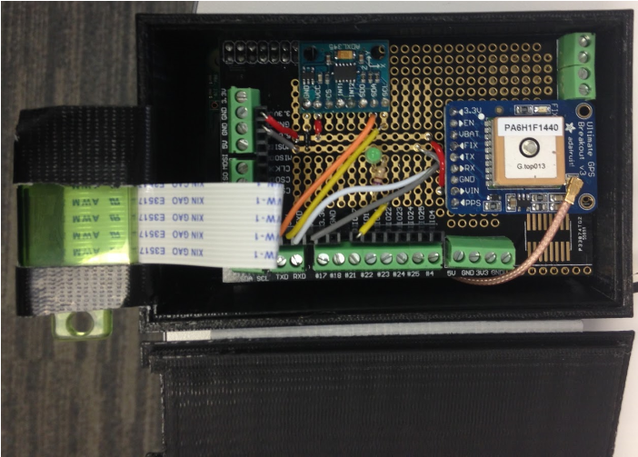

Figure 3: SQUID prototype with accelerometer, GPS, and camera shown.

## Data

The accelerometer measures acceleration of ±2G in the x, y, z direction at approximately 1500 Hz (1500 readings a second). Each second, the maximum variation from a baseline reading (a level measured when the device is stationary) in all directions is recorded. The latitude, longitude, vehicle speed, and timestamp of the reading is also recorded. Additionally, a photo is taken each second to provide a visual record, which corresponds to the underlying data.

The motivation for collecting image data is two-fold. The primary reason is that it provides literal "ground-truth" for the accelerometer data. This will allow operations personnel to quickly and remotely inspect road segments of interest without the need to send an inspector to verify the extent of the street defect.

The secondary reason is that not every pothole or street defect will be driven over, so a photographic record allows the data missed by the accelerometer to be captured. Again, this provides inspectors a comprehensive picture of the city streets, but also enables more advanced detection methods such as image recognition.

Currently, the data collected is stored locally on an SD card, which can then be transferred to a more robust machine for processing and analysis, either physically by removing the card or wirelessly over remote connection. However, work is being done to enable wireless transmission of data while the device is use. This will allow for near real-time analysis of street quality.

## Decisions

Currently the Street Conditions Observation Unit or SCOUT team within NYC’s Department of Operations is tasked with driving 6000 road miles of New York City’s roads and conduct windshield surveys to “visually-identifiable quality of life conditions like potholes, graffiti and defective sidewalks to 311 for City agencies to remediate” [15].

They achieve this daunting task with the help of 15 drivers and vehicles assigned to specific neighborhoods. If SQUID is mounted on these vehicles in the manner as described in this paper, controlled for position of the camera and calibrated to reflect consistent accelerometer readings, we envision the creation of an unprecedented rich dataset that contain only accelerometer data for overall ride quality but also complemented by a vast image store that can be used as to remotely verify the extent of the underlying defect in near real-time conditions leading to better situational awareness and addressing the missing denominator effect.

To demonstrate this, we used NYC Dept. of City Planning’s LION Street shapefile to create a hypothetic citywide pothole map. Each street segment on the shapefile was converted into a fixed set of points using the ArcGIS spatial software. Each point was then assigned a *Bumpiness* score simulating the jolt score implying that a pothole was at that location. This resulted in the creation of over 400,000 individual points with randomly assigned *Bumpiness* Scores. Each pointed also contained a latitude/longitude coordinate. This data was then exported to Tableau to create a decision support dashboard that allows for prioritizing specific street segments at multiple geographic representations (Borough, Zip Code, Community Board, Taxlot etc.). The Tableau dashboard also allows for the embedding of remotely stored images. So each of the 400,000 points could point to a distinct image that could display the underlying street defect. Furthermore, data created in this format could also be used for route optimization that could generate pothole spreadsheets used by the pothole fixing crews [16] deployed all across the city so that the time spent traveling to a location in need of repair is minimized and number of potholes worked on is maximized.

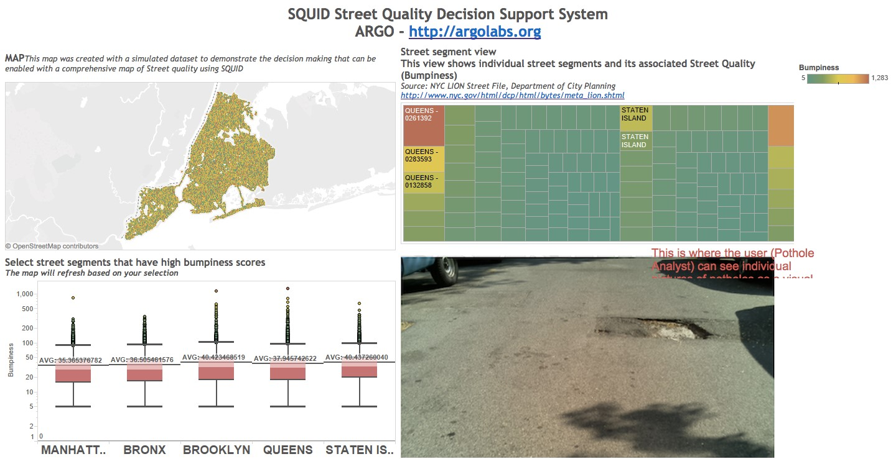

Figure 4: SQUID Decision Support System to illustrate the how decisions can be made around a citywide map of street defects. An interactive version of this dashboard is accessible at bit.ly/squid-sim

# EXPERIMENTATION

The design of SQUID as shown earlier was a result of multiple iterations of testing various facets of the device. We began with housing the device in a typical NYC delivery contained and experimented with solar batteries to make the setup as selfsustaining as possible. These early prototypes helped us quickly deploy the device in the field and understand the nuances and challenges of data collection in the field. Some of the initial findings included noise in the accelerometer data from poor housing and that the Raspberry Pi was performing inconsistently using a solar battery. These led us to specific improvements in the form of a 3d printed case with mounting holes to firmly contain the accelerometer and minimize noise from vibrations as well as rely on power from within the vehicle using the USB outlet. The SCOUT team exclusively uses Toyota Priuses for their operations – so we ensured that our testing was also done on a Pirus to ensure compatibility for a future pilot.

We also spent 40 hours of testing various mounting configurations for SQUID. Part of this challenge included weatherproofing and securing the device in a manner that was non

-intrusive to the SCOUT driver. This resulted in containing

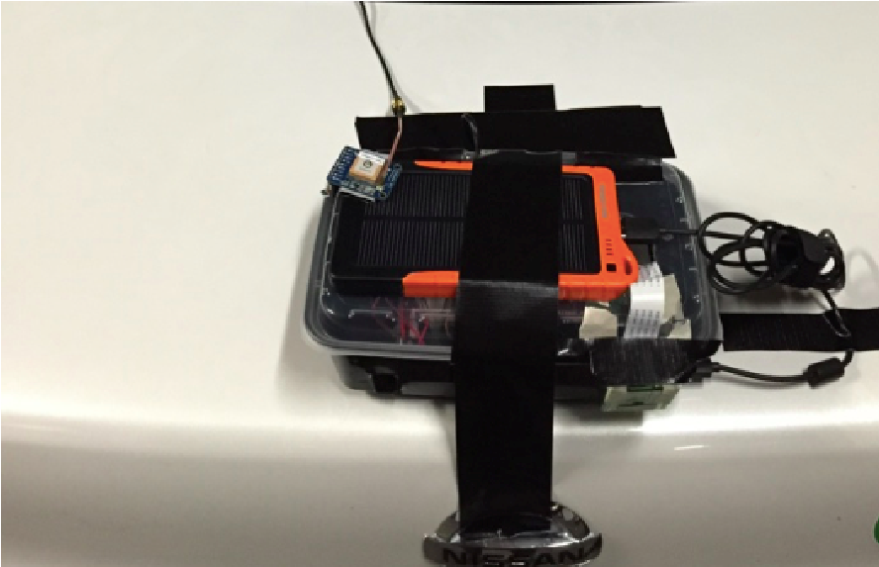

Figure 5(a)

Figure

5

(

b

)

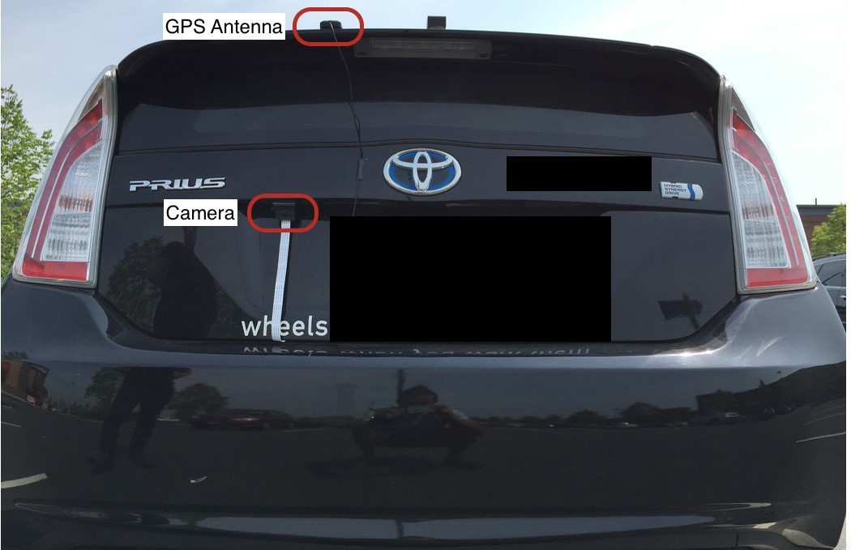

The results of many iterations around mounting and case design resulted in a version where the entire device is housed inside the vehicle with only the camera and GPS antenna exposed to the elements.

## Pilot

In May, 2015, we contacted the NYC Department of Operations and were able demonstrate the prototype as well as the envisioned outcomes to the SCOUT Team. The SCOUT team is interested in conducting a pilot where we deploy 2 SQUIDs on their vehicles over a continuous period to better understand how the sensor data can translate to operational decisions. We also met with the individual SCOUT drivers and introduced this concept to them to mostly positive feedback. The SCOUT drivers recommended that we include a button that they can press when visually identifying a street defect. This human-in-loop approach can potentially enrich the dataset without the need for advanced image processing techniques.

# RESULTS

We conducted several production level experiments and drove in excess of 100 miles of NYC roads with our prototype. Our mapping efforts allowed us to finalize decisions about camera & device placement. We were able to acquire consistent imagery and accelerator data driving around the Cobble Hill neighborhood in Brooklyn.

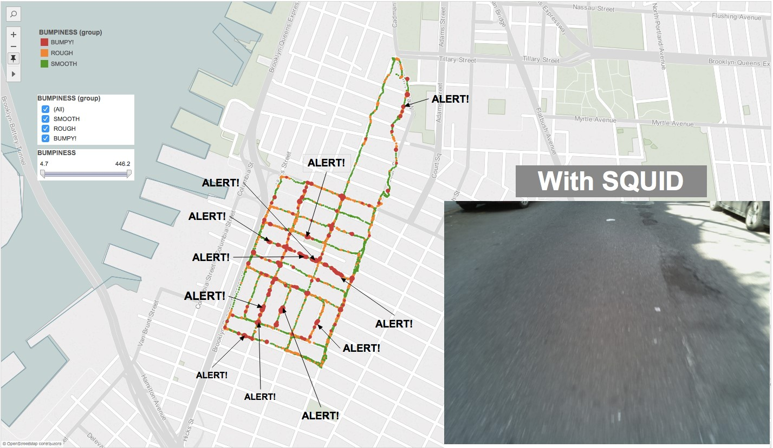

Figure 6: The aptly named Brooklyn neighborhood of Cobble Hill was our test site for conducting several experiments driving with SQUID. We were able to get consistent image position and accelerometer to differentiate one street from the next in terms of overall quality as well as identify the specific defects that caused spikes in the accelerometer reading.

Our data from the Cobble hill drives is hosted on Google Fusion

Tables and can be accessed here at bit.ly/argo_d4gx_fusion

# FUTURE WORK

Future work includes ensuring that the device is as plug and play as possible such that when the device receives power, it automatically connects to a wireless signal and begins recording data without human intervention. Our experimentation has also resulted in specific decisions to pause recording when the vehicle’s speed is less than 5 miles per hour. We are also testing around image quality, specifically around whether to preserve the image in color or gray scale for data management considerations. Transmitting the data in real time has been identified as a requirement and we have been testing using a *postgres* database hosted on Amazon Web services and use the AWS CLI interface that is native to Linux to transmit and sync accelerometer and imagery data into Amazon S3 storage buckets. Lastly, we are prioritizing our work around image processing especially around potholes. The academic research around potholes is sparse and the techniques have not been implemented on a large image database.

# CONCLUSION

In this paper we have explained the problem of the missing denominator around street maintenance decision-making. To this end we have reviewed existing approaches that are either not very precise or are too expensive to deploy at scale. We have explained in detail, the design and development of Street Quality Identification Device (SQUID) to address this problem by providing a cost effective scalable approach to passively and non intrusively collecting data about street surface quality with the intent to significantly improve reporting around street quality and bring unprecedented situational awareness to the domain to allow for better decision making and cost savings to city operations.

# ACKNOWLEDGEMENTS

We would like to thank our organizational adviser, Dr. Neil

Kleiman, NYU’s Center for Urban Science and Progress, Arlene Ducao at NYU’s Interactive Telecommunications program, Bob Richardson of NYC Technology Development Corporation, Dr.

Lucius Riccio, former commissioner of NYC Department of

Transportation for domain expertise and lastly the Street Conditions Observation Unit (SCOUT) team within the Mayor’s Office of Operations, City of New York.

# REFERENCES

1. Office of the New York City Comptroller. 2015, "Pothole City: A Data-Driven Look at NYC Roadways",

http://bit.ly/argo_d4gx_ref1

1. Office of the Mayor, NYC. 2015, "Transcript:

Mayor de Blasio Holds Press Conference on Investing $242

Million More in Repaving and Maintaining NYC

Roadways", http://bit.ly/argo_d4gx_ref2

1. TRIP. 2015, "Bumpy Roads Ahead:America’s

Roughest Rides and Strategies to Make our Roads

Smoother", http://bit.ly/argo_d4gx_ref3

1. Ingraham, C. 2015, "Where America’s worst roads are — and how much they’re costing us", The Washington

Post, http://bit.ly/argo_d4gx_ref4

1. Dempsey, M. 2015, "The NYC Pothole Problem",

American Automobile Association, http://bit.ly/argo_d4gx_ref5

1. TEDx Talks. 2015, "Pothole Analytics | Lucius

Riccio, Ph.D. | TEDxColumbiaSIPA" , http://bit.ly/argo_d4gx_ref6

1. NYC Department of Transportation. 2015, "DOT

Customer Service", bit.ly/argo_d4gx_ref7

1. Tufekci, Zeynep. “Big Questions for Social Media

Big Data: Representativeness, Validity and Other

Methodological Pitfalls.” arXiv Preprint arXiv:1403.7400,

2014. http://arxiv.org/abs/1403.7400

[9] Fund for the City of New York. 2008, "How Smooth are New York City's Streets?", http://www.fcny.org/cmgp/streets/pages/indexb.htm [10] Boston's Mayor's Office of New Urban

Mechanics. 2011, "StreetBump", www.streetbump.org/about

1. FUGRO., "Automatic Road Analyzer", http://www.roadware.com/

1. City of Oklahoma City. 2013, "Pavement and

Asset Data Collection Services (2013) -Revised", http://bit.ly/argo_d4gx_ref8

1. Adafruit. 2015,"Raspberry Pi 2 - Model B -

ARMv7 with 1G RAM", http://bit.ly/argo_d4gx_ref13

1. Mondon, M. 2015, “Pittsburgh Program Looks to Seal the Cracks in Urban Road Management”, Next City, http://bit.ly/argo_d4gx_ref14

1. NYC Department of Operations. 2015, "Customer

Service Group", http://bit.ly/argo_d4gx_ref15

1. Tumblr Storyboard. 2013, “A Day with New York City’s Pothole Repair Crew - Storyboard.”, http://bit.ly/argo_d4gx_ref16